1. RabbitMQ Web Interface can be used to manage and monitor the RabbitMQ service.
2. It runs on port 15672 by default.
3. Default username and password are “guest” and “guest”.
4. 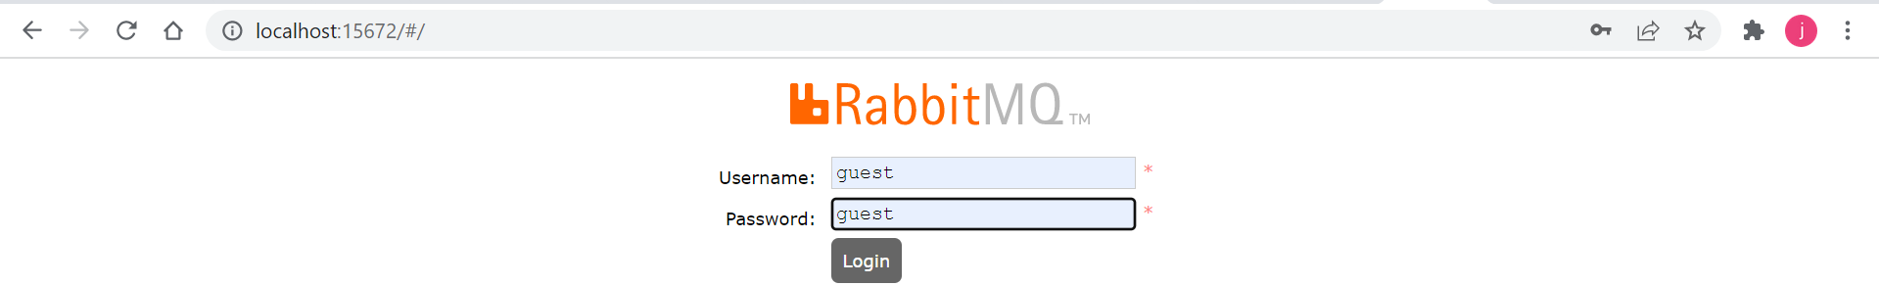
5. 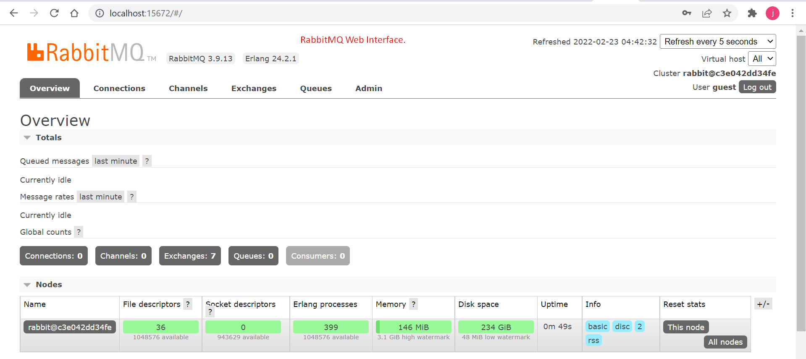
6. Let’s discuss the Header Bar.  
   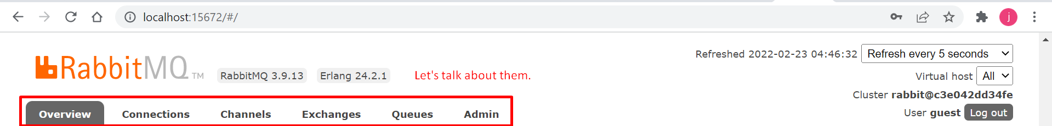
   1. **Overview**:
      1. 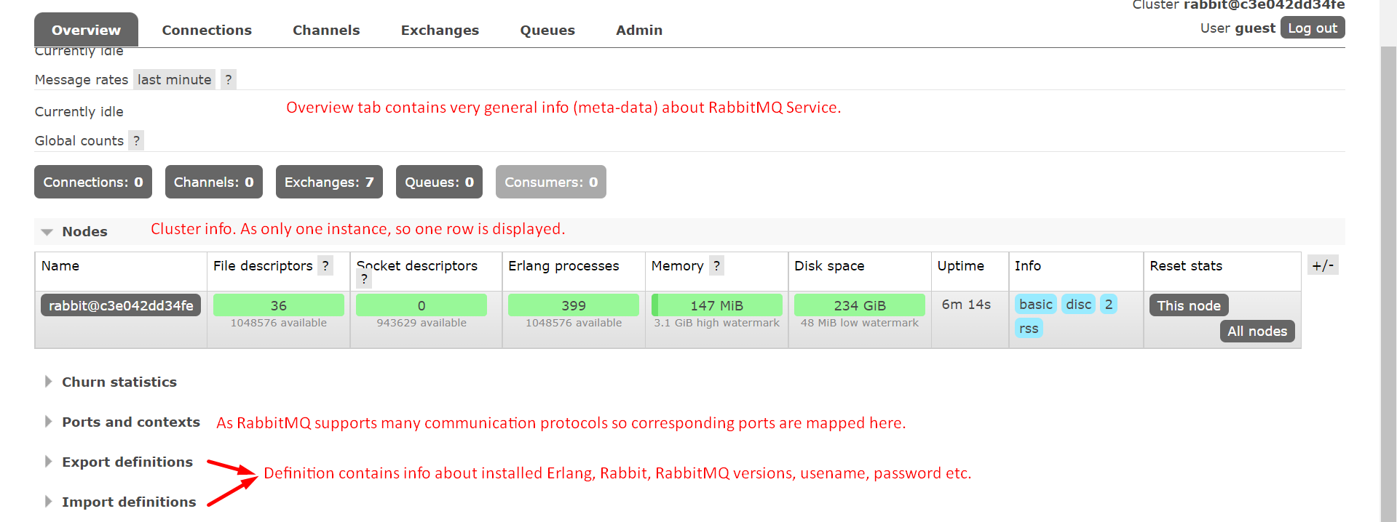
   2. **Connections**:  
      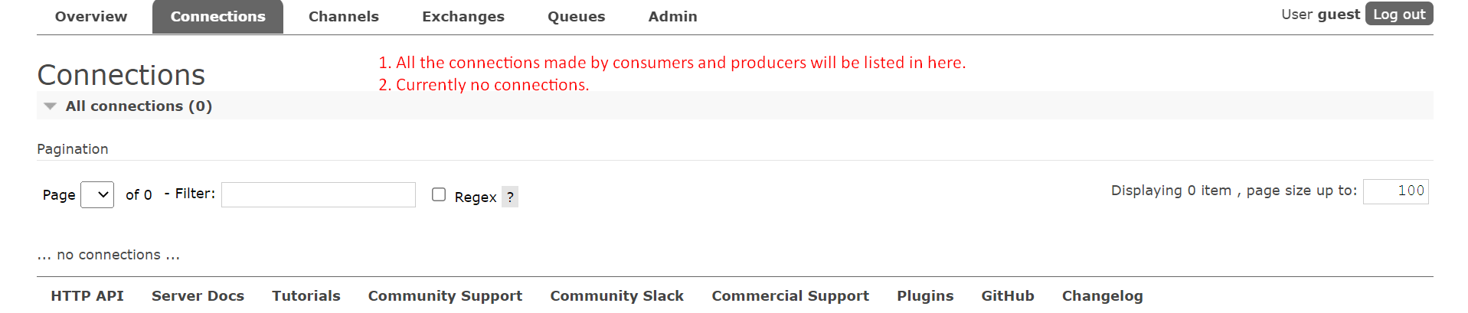
   3. **Cannels:**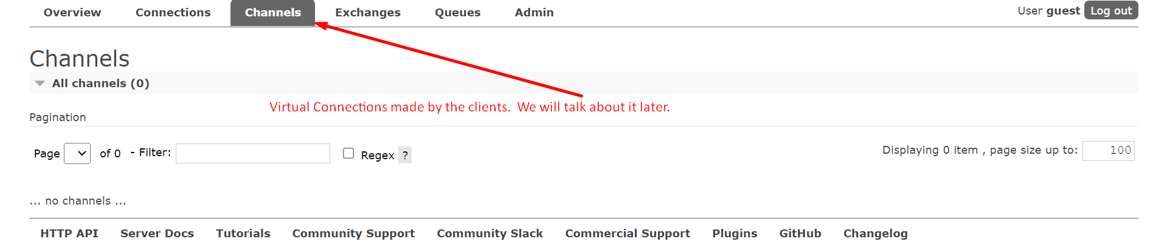
   4. **Exchanges:**  
      Message routing elements of RabbitMQ.  
      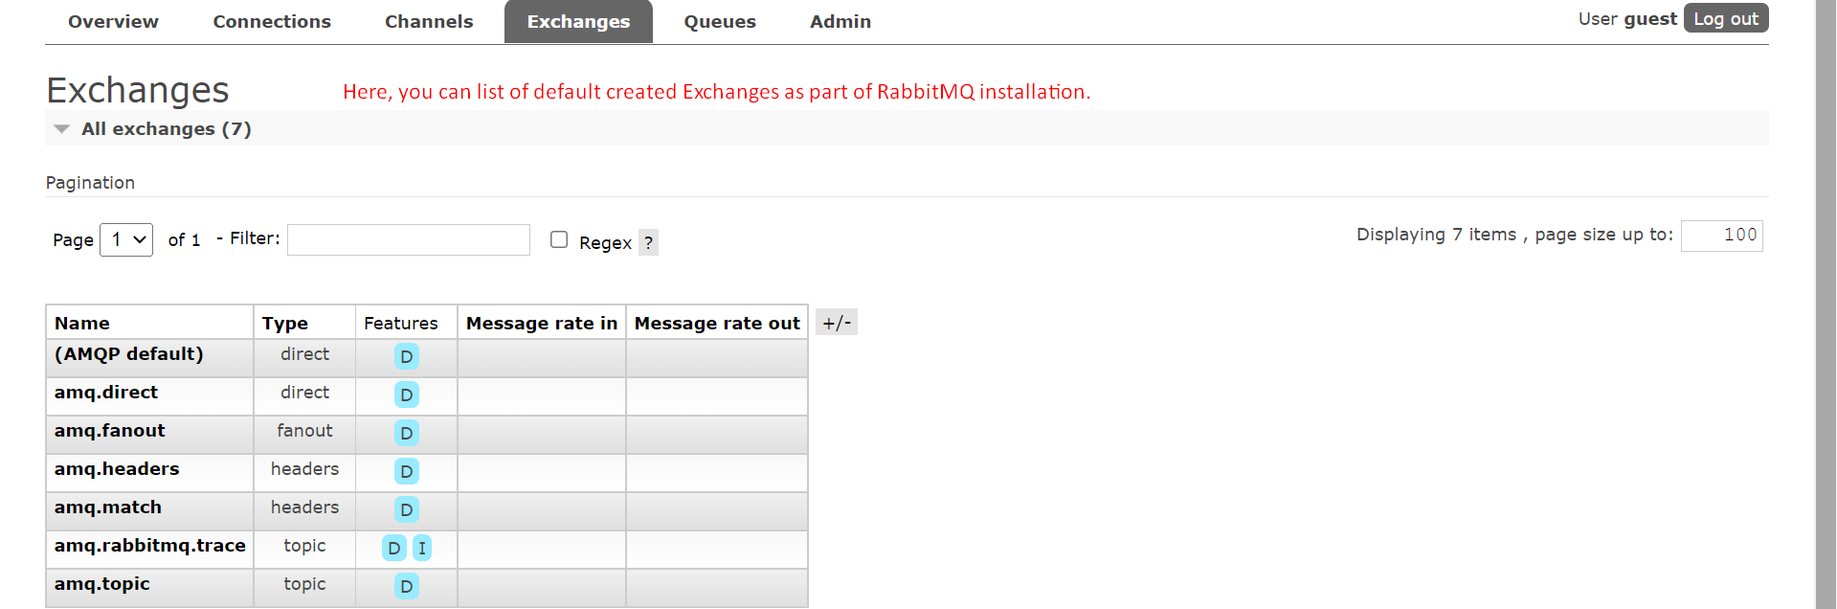
   5. **Queue:**  
      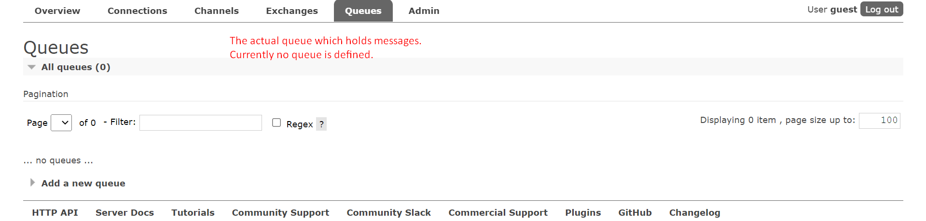
   6. **Admin:**  
      To manage users, Virtual Hosts, Future Flex, Policies, Limits, and the cluster.  
      